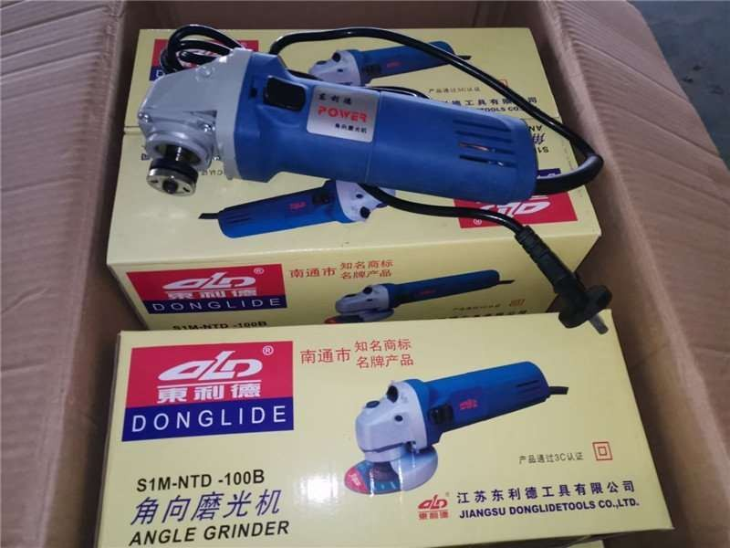

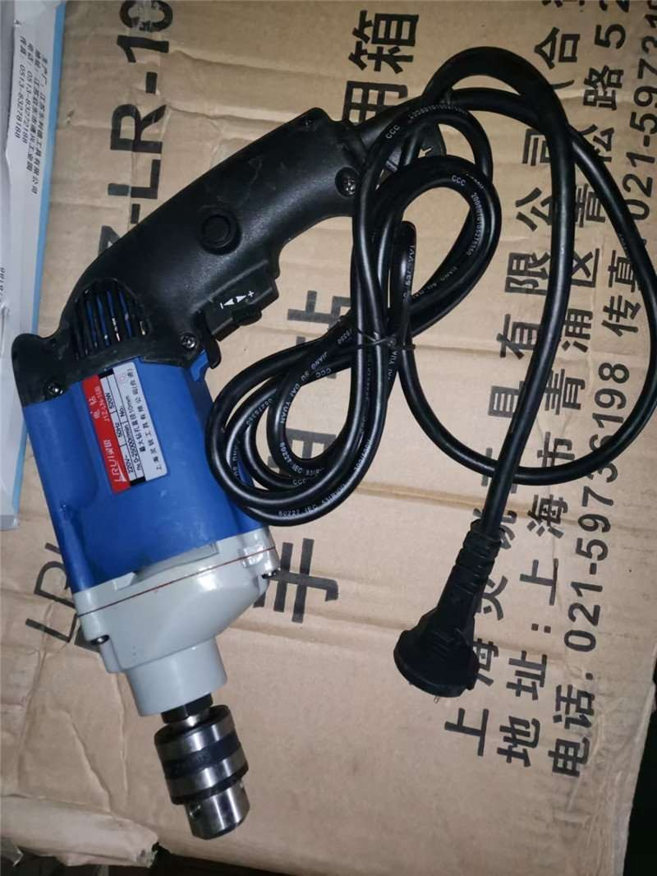
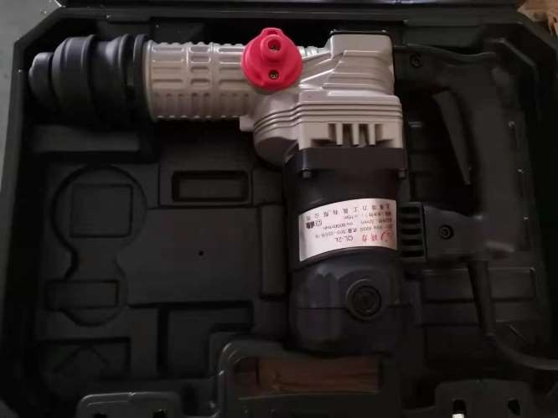
Item#3
Item#1

Electric Drill

Power:520W Voltage: 220V 0-25000r/min

Qty : 15,000pcs

Pricce : USD9.85/pc EXW

Item#2

Angle Grinder Voltage: 250V Qty : 25,000pcs
Pricce : USD11.46/pc EXW

demolition hammer Voltage: 220V Power : 600W

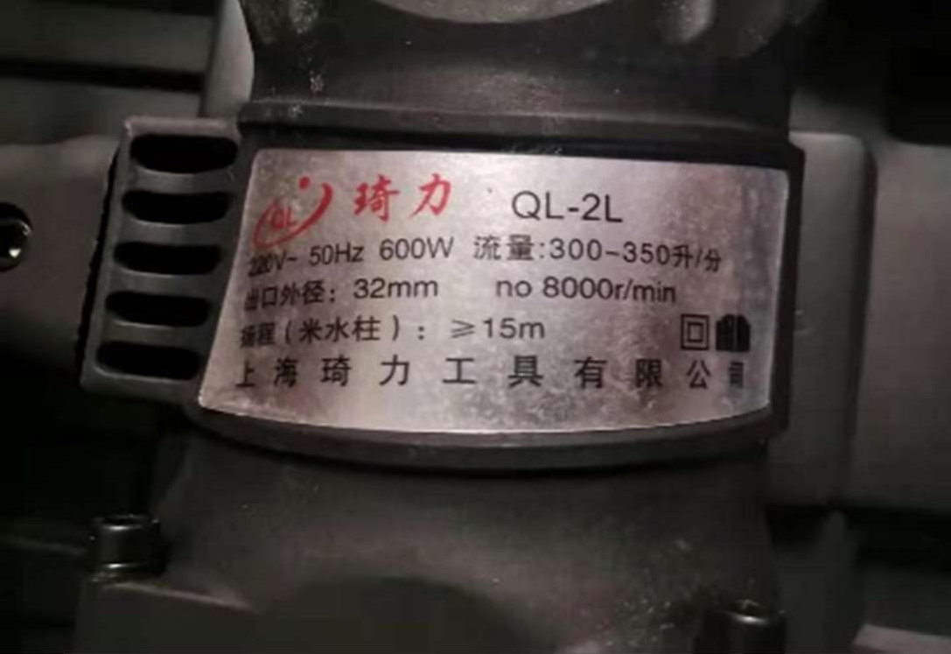
Qty: 6000pcs

Price : USD14.85/pc EXW

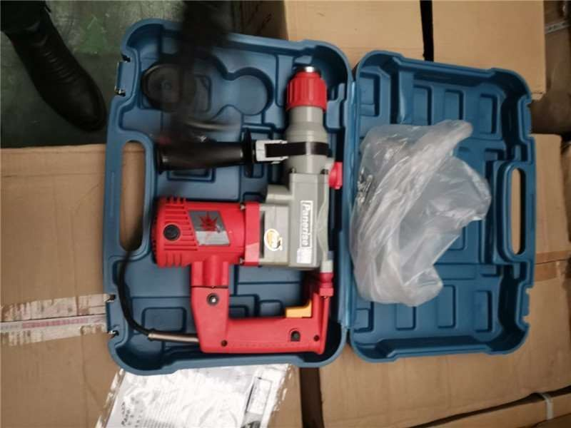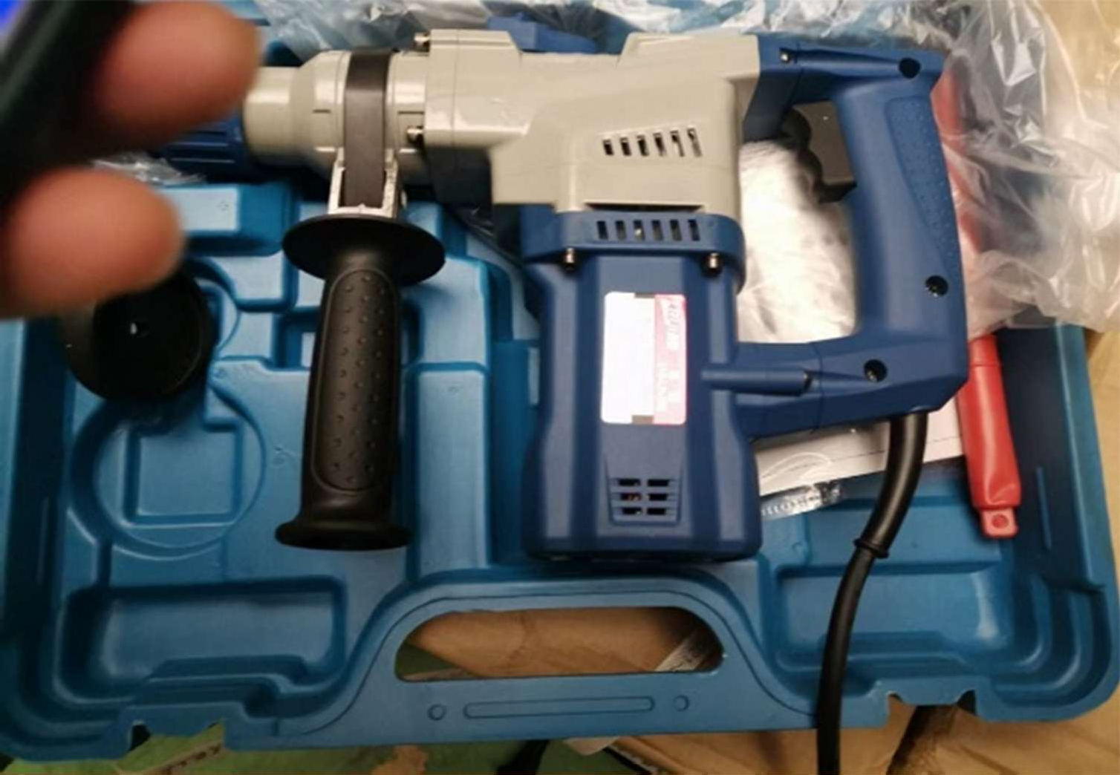

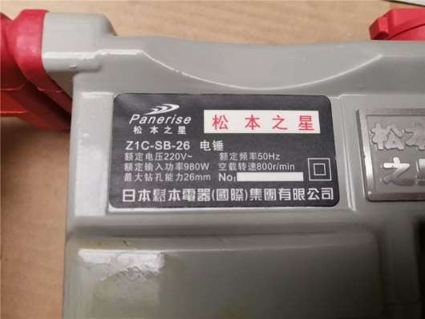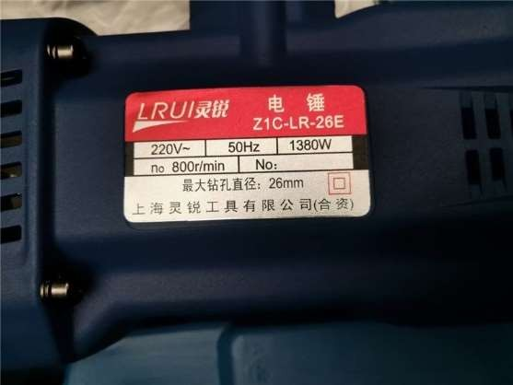

Item# 4

Rotary Hammer Qty: 14000pcs
Price : USD22.39/pc EXW

